Detailed Design Specification

Human Resource Management
The information contained in this document is the property of HRM_PIM. Except as specifically authorized in writing by HRM_PIM, the holder of this document shall keep all information contained herein confidential and shall protect same in whole or in part from disclosure and dissemination to all third parties.

6/6/2012

Table of Contents
1. Introduction 3
1.1. Purpose 3
1.2. Goals and Objectives 3
1.3. Constraints 3
1.4. Intended Audience and Reading Suggestions 3
2. Architectural and Component-Level Design 4
2.1. MVVM Pattern 4
2.2. Architecture diagram 5
2.3. Description of Components 6
2.4. Requirements Traceability Matrix 6
3. File List Description 6
4. Detail Design 6

History revision
Name | Date | Version | Description
Dang Nguyen | 3/6/2012 | 1.0 | Introduction  Architectural and component level design
Dang Nguyen | 3/8/2012 | 1.1 | File list design
Dang Nguyen | 3/9/2012 | 1.2 | Prepare detail design
Dang Nguyen | 3/10/2012 | 1.3 | Design information management
Dang Nguyen | 3/21/2012 | 1.4 | Design employee code setting  Design supported people management  Design family relationship management
Dang Nguyen | 3/23/2012 | 1.5 | Design column setting
Dang Nguyen | 3/24/2012 | 1.6 | Design certificate management  Design staff history  Design reward management  Design staff internship management  Design training result management  Design facilitate management
Dang Nguyen | 3/28/2012 | 1.7 | Design mobilization management  Design other management  Design subject management
Dang Nguyen | 3/30/2012 | 1.8 | Design penalty management
Dang Nguyen | 3/31/2012 | 1.9 | Design syllabus management  Design work management  Design income management
Dang Nguyen | 4/3/2012 | 1.10 | Design union Management  Design task note book management  Design internal training management  Design lecture position management
Dang Nguyen | 4/4/2012 |  | Design science research management  Design master thesis guideline management
Dang Nguyen | 4/6/2012 | 1.11 | Design training course management  Design emulation management  Design trade union management  Design salary coefficient management
Dang Nguyen | 4/7/2012 | 1.12 | Design communist party management
Dang Nguyen | 4/10/2012 | 1.13 | Design lecture probation management  Design article management
Dang Nguyen | 4/11/2012 | 2.0 | Review detail design

Introduction

Purpose
This document presents the detailed design for the HRM system. The purposes of this document are as below:
- To supports the Developer having the overall software design. Based on this document, Developer will be able to implement the system easily.
- To supports Developer writing Unit test.
- To supports tester (QC) writing Integration test.

Goals and Objectives

All components to be developed will be enumerated and described within this document to the level of detail necessary to begin implementation.

Constraints

This document will address functional requirements as documented in the SRS.

Intended Audience and Reading Suggestions

Intended Audience | Reading Suggestions
Developer | Overall description of design of the system
Quality control | Overall description design to make Integration test

Architectural and Component-Level Design

MVVM Pattern
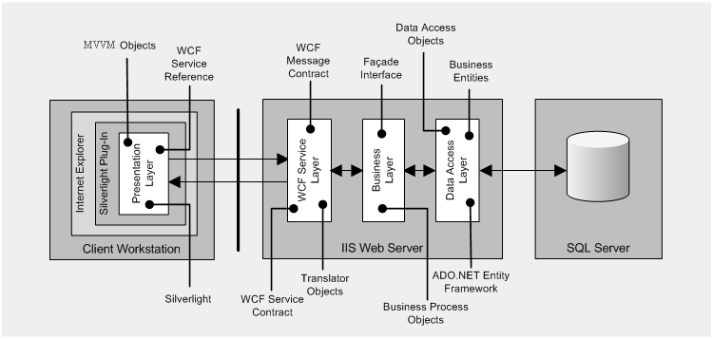

Architecture diagram
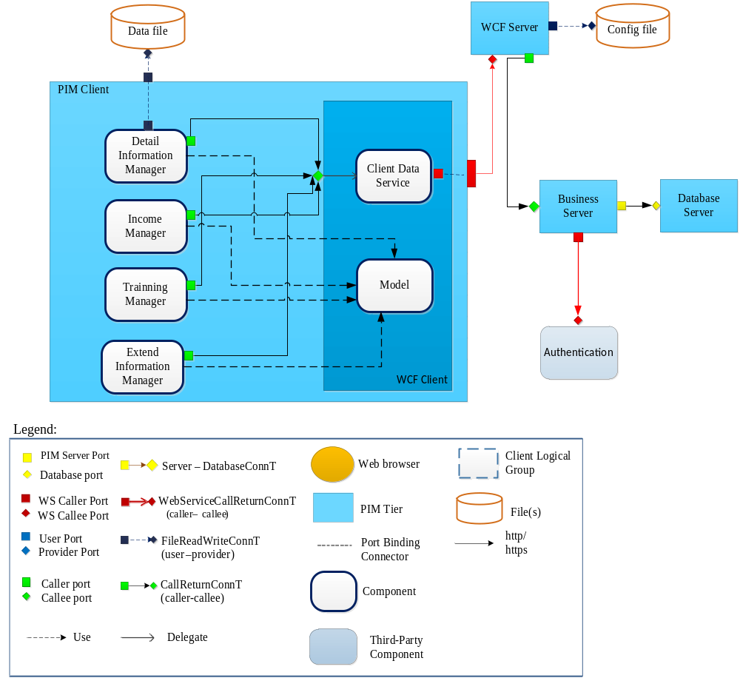

Description of Components
Reference to 6.7: Module views of HRM- PIM system in HRM_Architecture Design Document

Requirements Traceability Matrix
Reference to Requirements Traceability in File List

File List Description
Reference to File List

Detail Design
Reference to Detail Design

